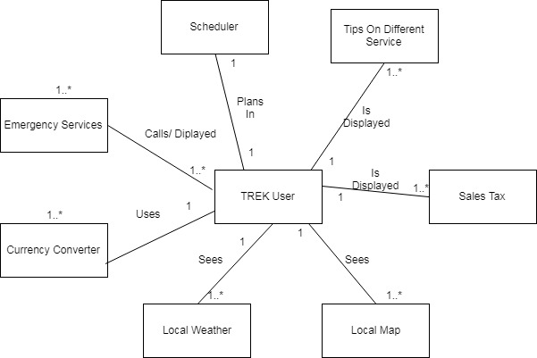

|  |
| --- |
| **TREK User** |
| - Time : Date  - Name: String  - Email : String  - Phone : int  - Username: String  - Password: String |
| +getTime()  +getName()  -getEmail()  -getPhone()  -getUser()  -getPassword() |

|  |
| --- |
| **CurrencyConverter** |
| +currentCurrency: double  +convertedCurrency: double |
| +setCurrency(currentCurrency: double)  +setconvertedCurrency(convertedCurrency: double)  +convert(currentCurrency: double, convertedCurrency: double)  +getConverted() |

|  |
| --- |
| **SalesTax** |
| +Currency: double  +Zip: int  +City: String  +Tax: double |
| +setCurrency(Currency: double)  +setZip(Zip: int)  +setCity(City:String)  +getTax1(City:String)  +getTax2(Zip:int)  +AddTax(Currency : double, Tax: double)  +getFinal() |

|  |
| --- |
| **Tip** |
| +Currency: double  +Service: String  +Tip: double  +Satisfaction: Boolean  +Recommend: int |
| +setCurrency(Currency: double)  +setService(Service:String)  +setSatisfaction(Satisfaction:boolean)  +setTip(Service:String, Satisfaction:boolean, Recommend: int )  +AddTip(Currency : double, Tip: double)  +getFinal() |

|  |
| --- |
| **LocalMap** |
| +Location: MapAPI  +Attractions: String |
| +setLocation(Location:MapAPI)  +Route()  +setAttractions(Attractions:String)  +getRecommendation(Location:MapAPI, Attraction: String) |

|  |
| --- |
| **LocalWeather** |
| +Location: WeatherAPI  +Update: boolean |
| +setLocation(Location:WeatherAPI)  +getWeather(Location:WeatherAPI)  +getWeatherUpdate(Location:WeatherAPI, Update: boolean) |

|  |
| --- |
| **Scheduler** |
| +Plans: String  +Events: String  +Reminder: String  +Important: String  +Day: Date |
| +AddPlans(Plans: String)  +AddEvent(Events:String)  +AddReminder(Reminder:String)  +AddImportant(Important:String)  +SetDate(Day:Date, Plans:String)  +SetDate(Day:Date, Events:String)  +SetDate(Day:Date, Reminder:String)  +SetDate(Day:Date, Important:String)  +EditPlans(Plans: String)  +EditEvent(Events:String)  +EditReminder(Reminder:String)  +EditImportant(Important:String)  +getPlans()  +getEvents()  +getReminders()  +getImportant() |

|  |
| --- |
| **EmergencyServices** |
| +Location: MapAPI  +Phone: int |
| +LocateNearest(Location:MapAPI)  +Route()  +setPhone(Phone:int)  +DialPhone() |